How to add additional storage in lunix server

Step 1 : Add storage in vmware edit option – Add Hard Disk – New standard hard disk – Eg : 100Gb

Step 2 : login via ssh with that server

Step 3: df -h

Step 4 : fdisk -l

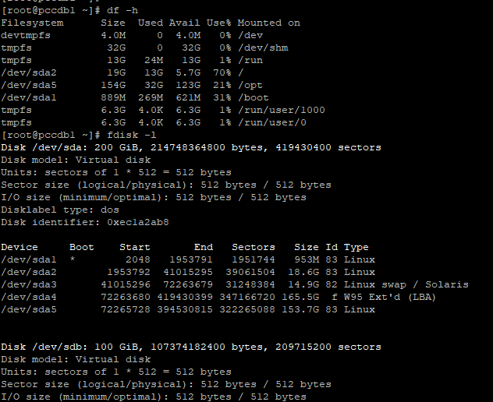

Step 5 : Need to create a directory for the name

mkdir /opt/backup

fdisk /dev/sdb

Step 6:

Command (m for help) : n (N is for new storage creation)

Partition type

p primary (0 primary, 0 extended, 4 free)

e extended (container for logical partitions)

Step 7 :

Select (default p) : p

Step 8 :

Partation Number (1-4, default 1) : 1

First sector (2048-209715199, default 2048): 2048

Last sector, +/-sectors or +/-size{K,M,G,T,P} (2048-209715199, default 209715199): 209715199

Command (m for help): w ( W for write the hard disk command)

The partition table has been altered.

Calling ioctl() to re-read partition table.

Syncing disks.

Step 9: fdsik -l

Output : Disk /dev/sda: 200 GiB, 214748364800 bytes, 419430400 sectors

Step 10 :

mkfs.ext4 /dev/sdb1

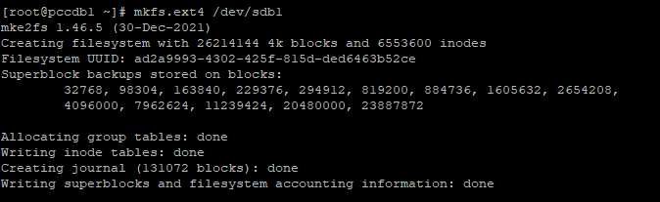

Step 11 :

[root@pccdb1 ~]# /dev/sdb1 /opt/backup/

-bash: /dev/sdb1: Permission denied

If the permsiion denied error occurs use this commands

Step 12 :

mkdir -p /opt/backup

Step 13 :

mount /dev/sdb1 /opt/backup

mount: (hint) your fstab has been modified, but systemd still uses

the old version; use 'systemctl daemon-reload' to reload.

Step 14 :

mount -t ext4 /dev/sdb1 /opt/backup

Step 15:

Vi /etc/fstab

Step 16:

mount /dev/sdb1

Step 17 :

df -h – Partition is created

